The Da Vinci Self-Supporting Bridge Initiative

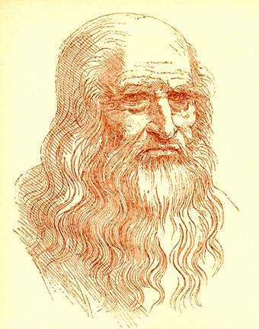

Background:

The Medici Family and the Borgia Family were rivals back in Renaissance Italy in 1485. They were always competing for power and were often fighting with each other.
Leonardo Da Vinci, artist, scientist, and architect was commissioned by the Borgia family to design light and strong arched bridges for military purposes. He was charged with the task of building structures that could be built and taken down quickly. His designs could be put together without any connecting materials. They were strong and could be built with materials that were easy to find and easily transported.

Setup:

Place half the materials for the bridge on one side of a 10’ x 12’ tarp and the other half on the other side. Each team will need 6 precut 2x4s, 3 wood dowels, 2 webbing pieces and a rope. Divide your group into 2 teams, have them move to one side of the tarp or the other.

The Scenario:

The blue Tarp represents the Arno River in Florence, Italy.
The group on one side of the river (The Medicis) meets the group on the other side (The Borgias). There has been a terrible rainstorm that has flooded the normally quiet river and prevents either group from wading through the river to get back home for the night. Earlier in the day Leonardo left the pieces of the bridge he built by the shore of the river, half the materials on one side, half on the other.

Task:

The two rival families must put their differences aside, figure out how to put the bridge together and connect the two halves so that they can span the river. Only then can they each cross and get back to their warm homes and families for the night. It’s getting darker and colder by the minute. The bridge inspector (you) should inspect the bridge for safety before anyone actually gets on it.

Facilitator Notes: Below are two models of Da Vinci’s Bridge. These are for your reference only. Do not show the pictures to your teams.
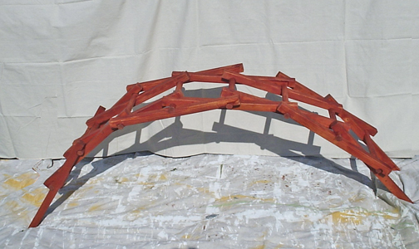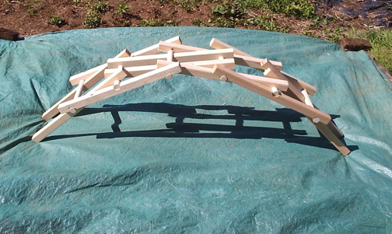
You may want to copy the crude diagram below and cut it into pieces, offering to reveal one picture at a time to assist struggling teams. There are actually 2 more sets of rungs on each side of the real bridge than show in the diagram. By the time you get to the 5th or 6th diagram they should have it figured out. Be patient though, and let them struggle for a while.
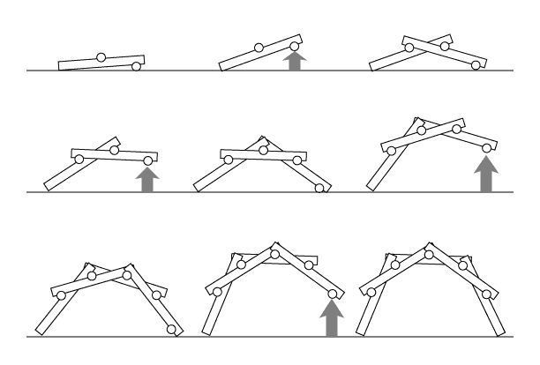
Safety notes: Only one person should be crossing at a time. Before anyone crosses, the facilitator should direct the group to set up in proper spotting position on both sides of the bridge with “bumpers” up to keep each crosser safe. Watch for tipping of the bridge – you may want to steady the structure.
Credits: I first learned about the DaVinci Bridge from Gus Hemmer, Associate Director of Campus Recreation at Longwood University, VA on ropes-list@ropesonline.org.

