Mousetrap Trust Sequence

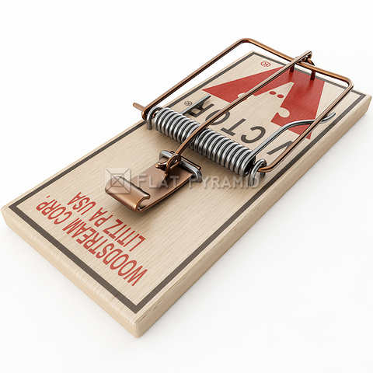

- Have participants stand in a circle.
- Each participant will be asked to get his/her own mousetrap.
- Facilitator Explanation – This activity is a trust activity. You must trust yourself. You must trust those in your group. In order to build trust with others you must trust yourself first. This activity will model some of the problems or obstacles in the way when working to establish trust.
- Stage 1 – explain and demonstrate how to set a mousetrap. Facilitator should walk around and assist group after demonstrating once or twice how to correctly set the trap. When everyone has mastered setting the trap move on to the next stage.
- Stage 2 – Ask everyone to set their traps. Participants should then place the trap in their right hand: palm up, trap up. Once they’ve done this, facilitator should demonstrate how to cover their trap with their free hand. Facilitator then asks everyone to do the same as he/she has done on the count of 3. Direct the group to hold onto the traps until the next step. Once this is accomplished, group will reform circle.
- Stage 3 – On the count of three the entire group will toss their mousetraps into the center of the circle.
- Stage 4 – Group recollects traps, resets traps, and places set trap in their right hand. Participants must now find a partner. Partners face each other and when they are ready, place their free hand over their partners trap and prepare to toss. When group is ready, everyone throws traps into center of circle on the facilitator’s count.
- Stage 5 – Group recollects traps, resets traps, places trap in right hand, and reforms circle – shoulder to shoulder. Once in circle, each person will cover the person to their left’s mousetrap on the facilitator’s count. Everyone’s trap should now be covered. On the count of three, group slowly lowers their hands and tosses their traps into the center.

Debrief : Focus on the role risk plays in this activity. What does this activity show you about risk? What helps a person manage risk? How was the risk involved different for each participant? Who felt uncomfortable? What did you do about it?

Credits: I originally learned mousetraps activities from Jim Cain.

